Ex1

3 use <make> system will find makefile file auto in current dir

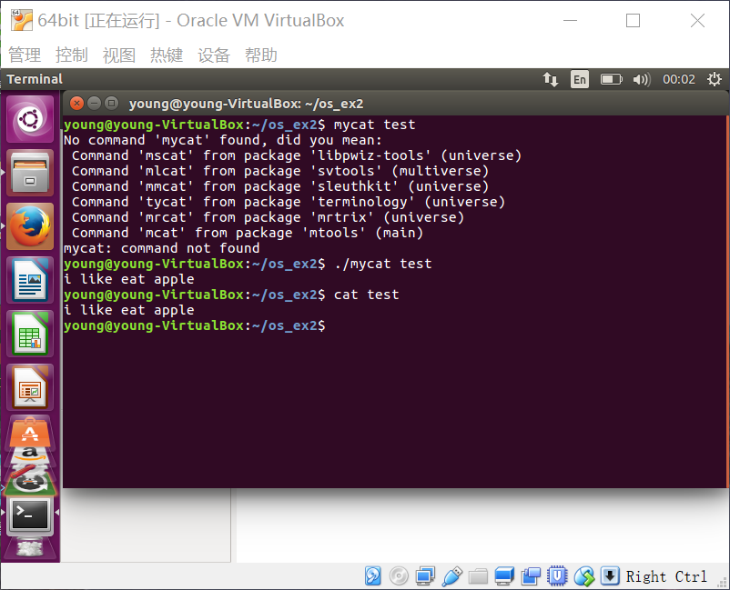

Has the same effect with <cat> command